1. With the exception of simplest cases of linear polymers we cannot compose a deterministic representation of a general polymeric macromolecule.
2. We can still characterize a polymer by including all its characteristics into SPL. These characteristics will include all known SRU, end- and joint- units, degrees of polymerization, all other essential characteristics.
3. SPL description of polymer should be built on assumption that polymer is a set of moieties – some of which are well-defined fragments (end and joint units), some of which are SRUs.
4. Only linear SRUs should be separated and canonicalized
5. General approach to canonicalize SRU is:
   1. Take SRU of length N and propagate to the length of 2N
   2. Move frame N steps from left to right, then in reverse order and choose a canonical (in terms of InChI) chain
   3. Locate canonical chain on 2N fragment
   4. See if end units modification is necessary by cutting or attaching parts of the polymeroic chain
   5. Reconstruct new polymeric chain with adjacent units
   6. Repeat if necessary for all SRUs of branched polymer
6. Polymeric moiety is radical or bi-radical with added H

3C96Y1D5T4

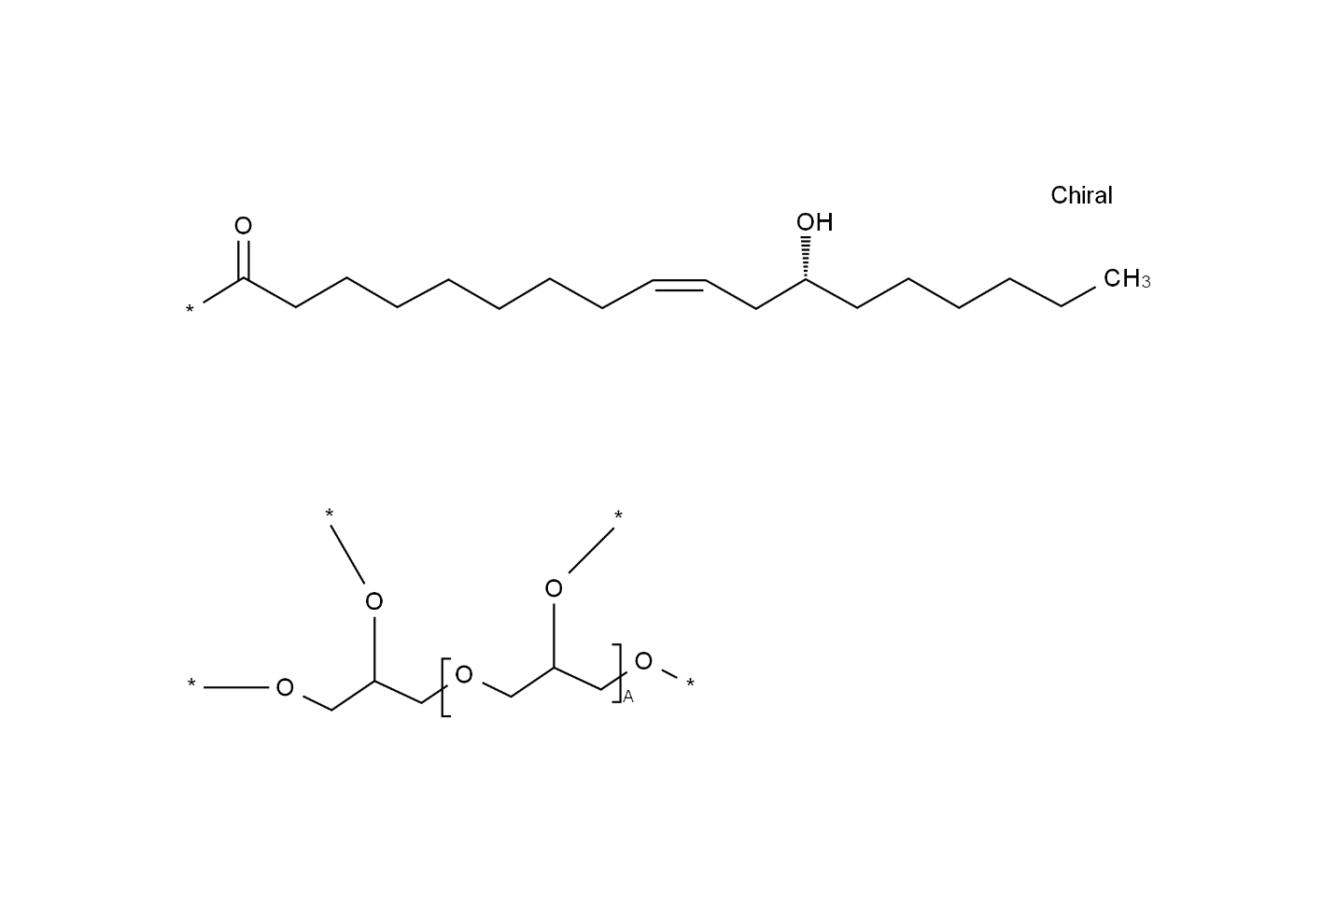

3QOO3WZP6Y

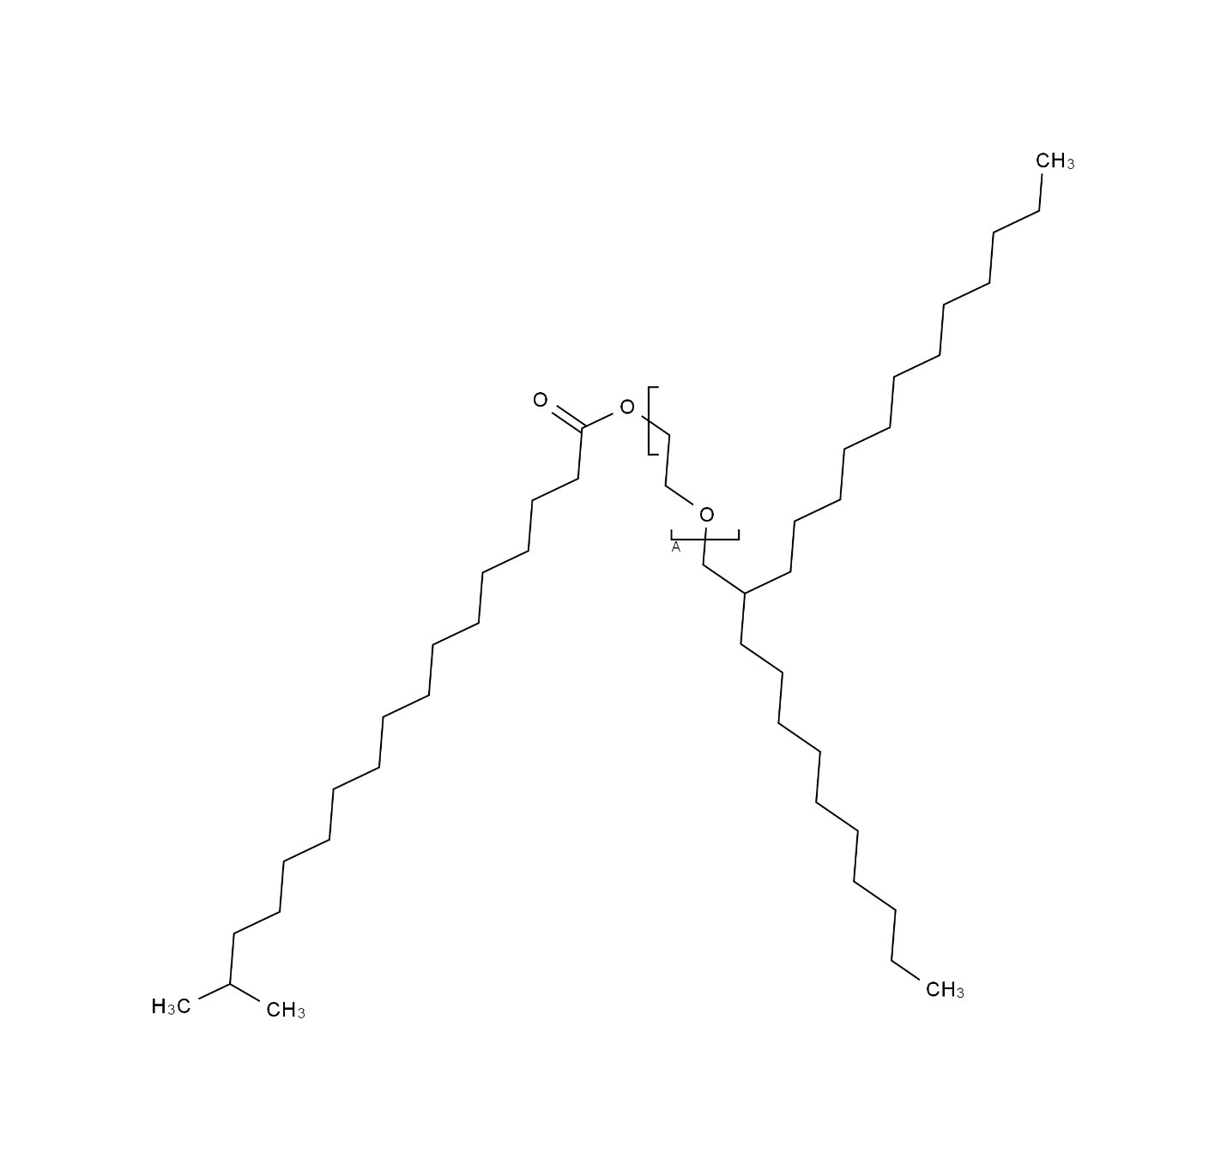

3V7U636DWN

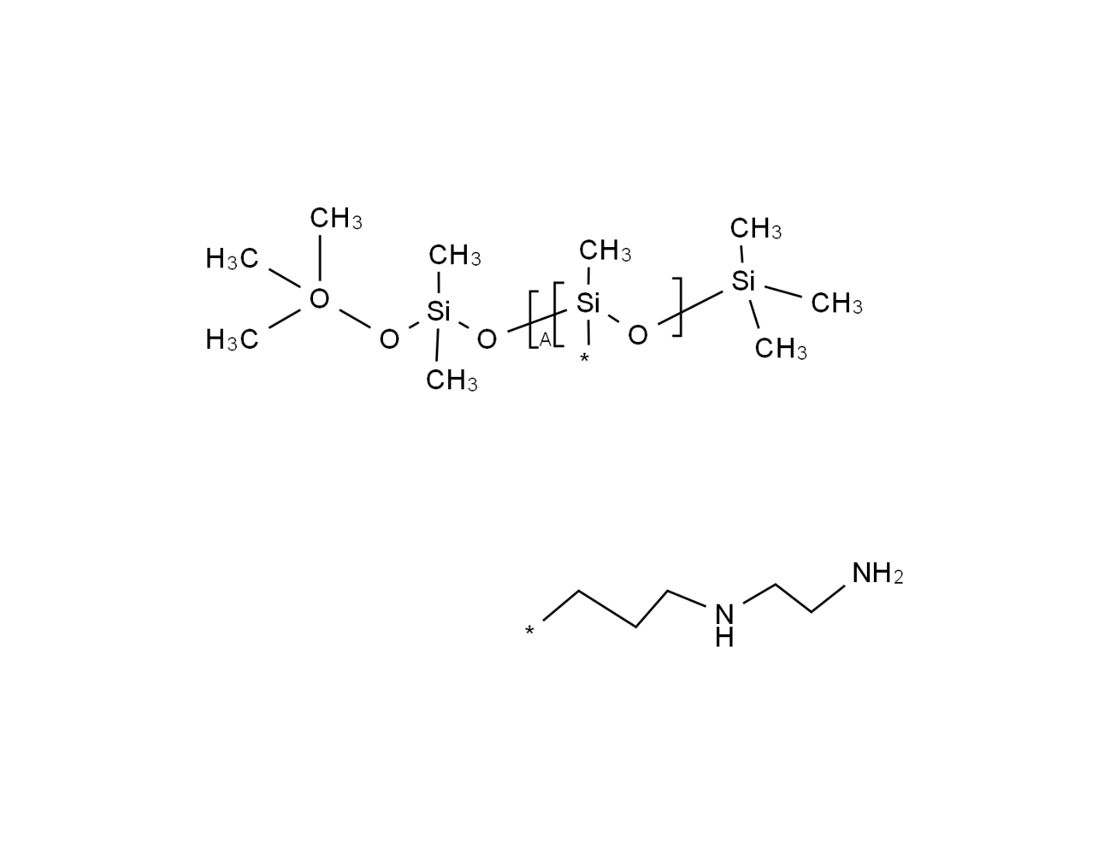

3YWG8XYT8H

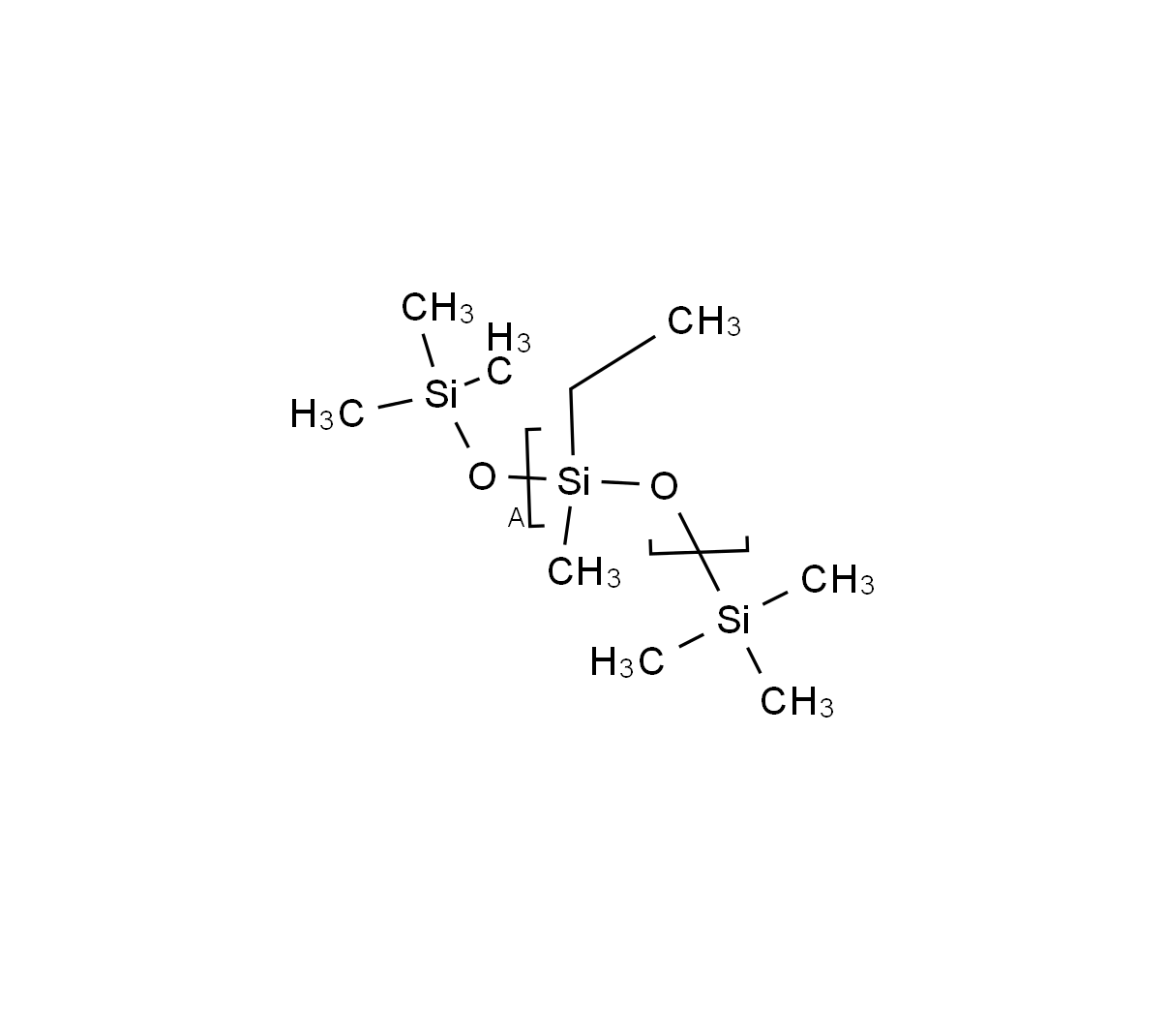

4IN301M0KJ

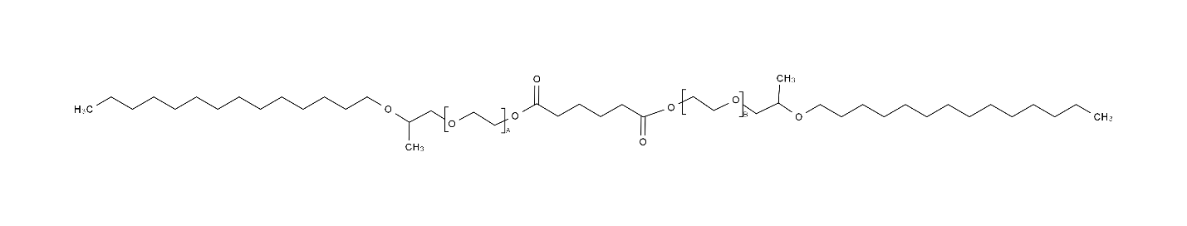

4ROB1M2DHD

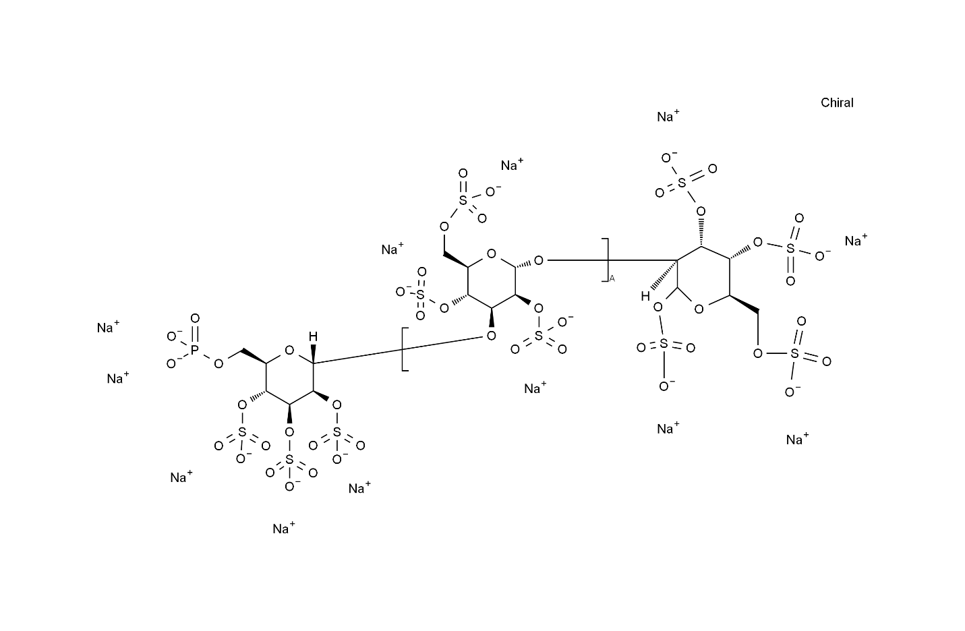

05Q25F6XJ3

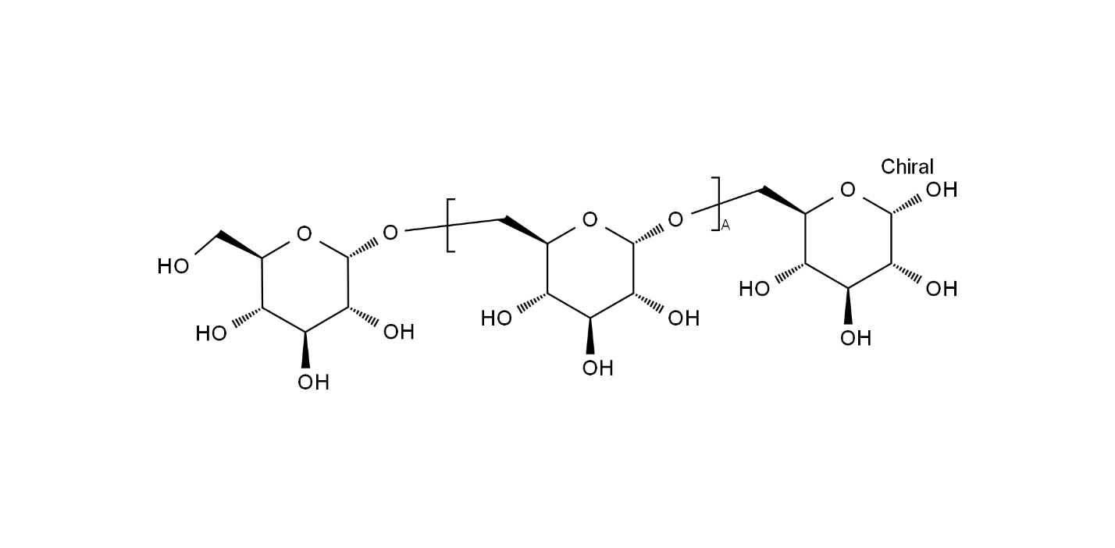

5L694Y0T22

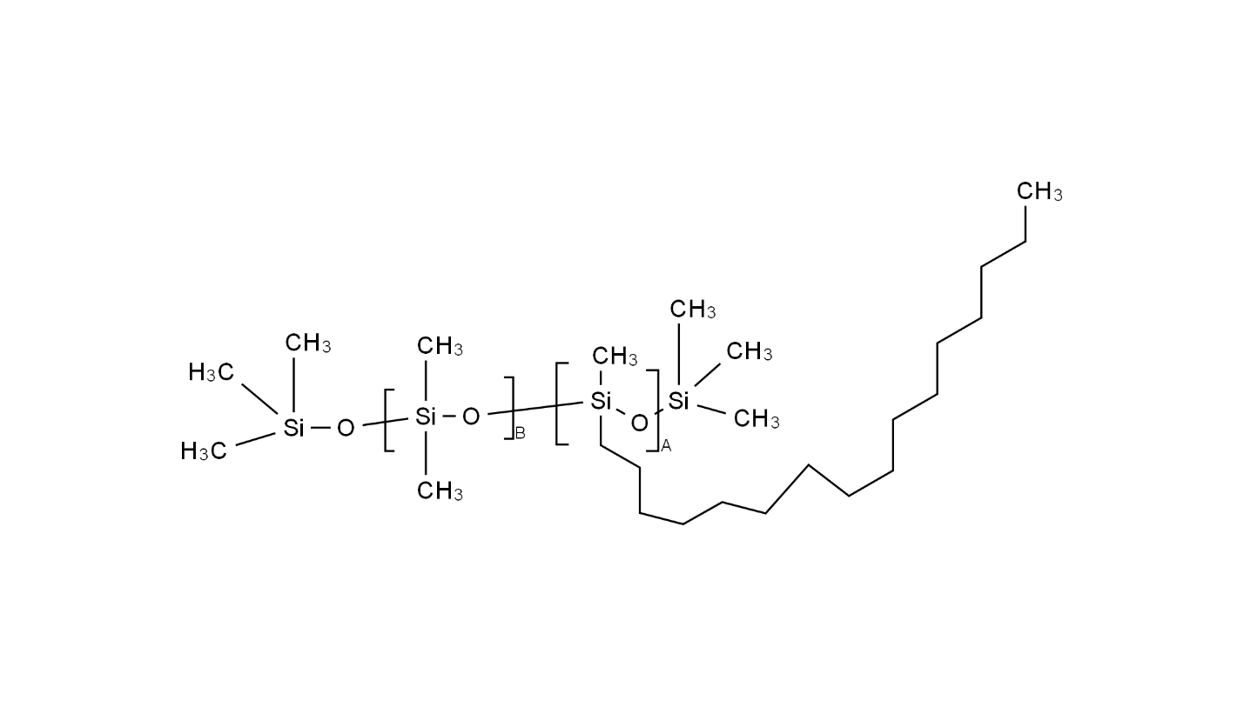

5YSH70HE6K

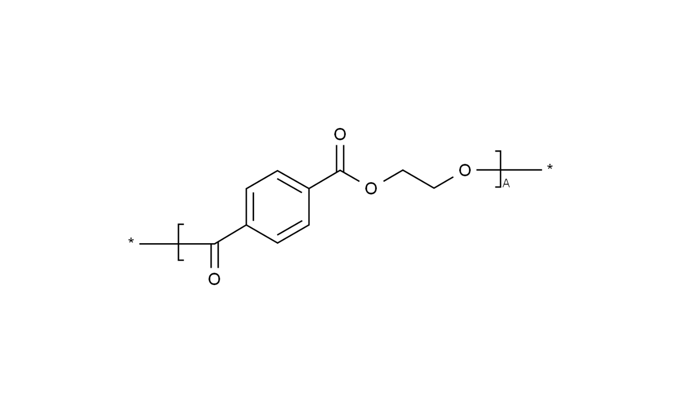

8B8GHO5O27

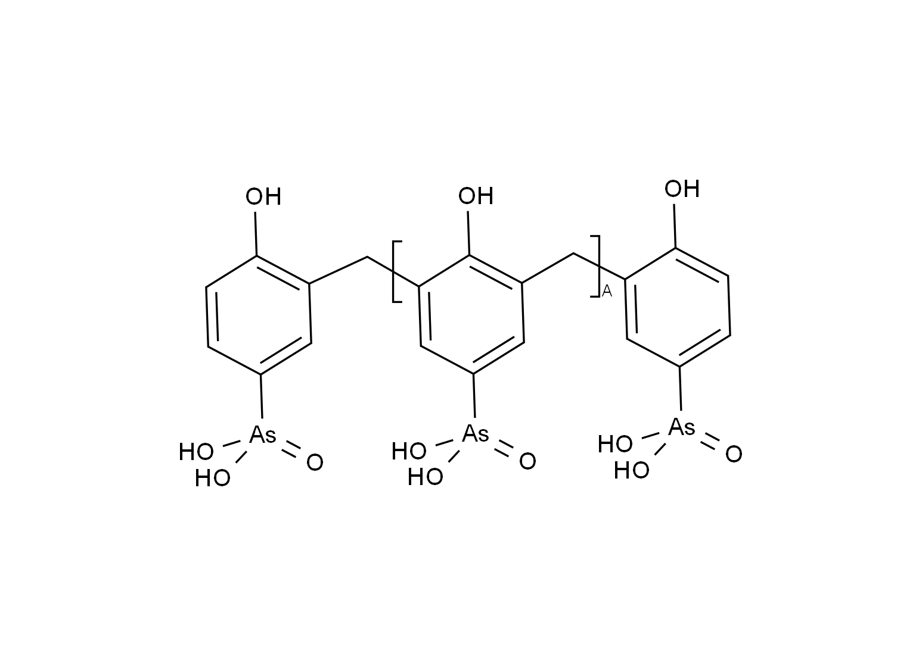

8CAC4NQ872

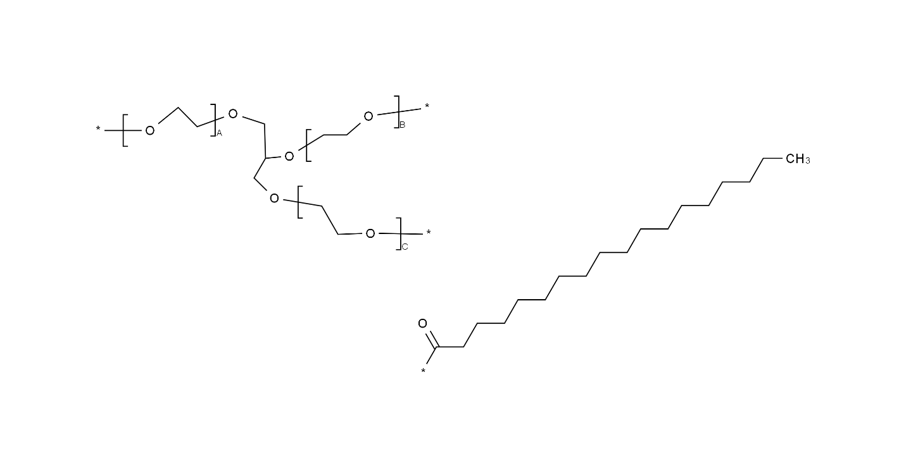

8ZQ0AYU1TT

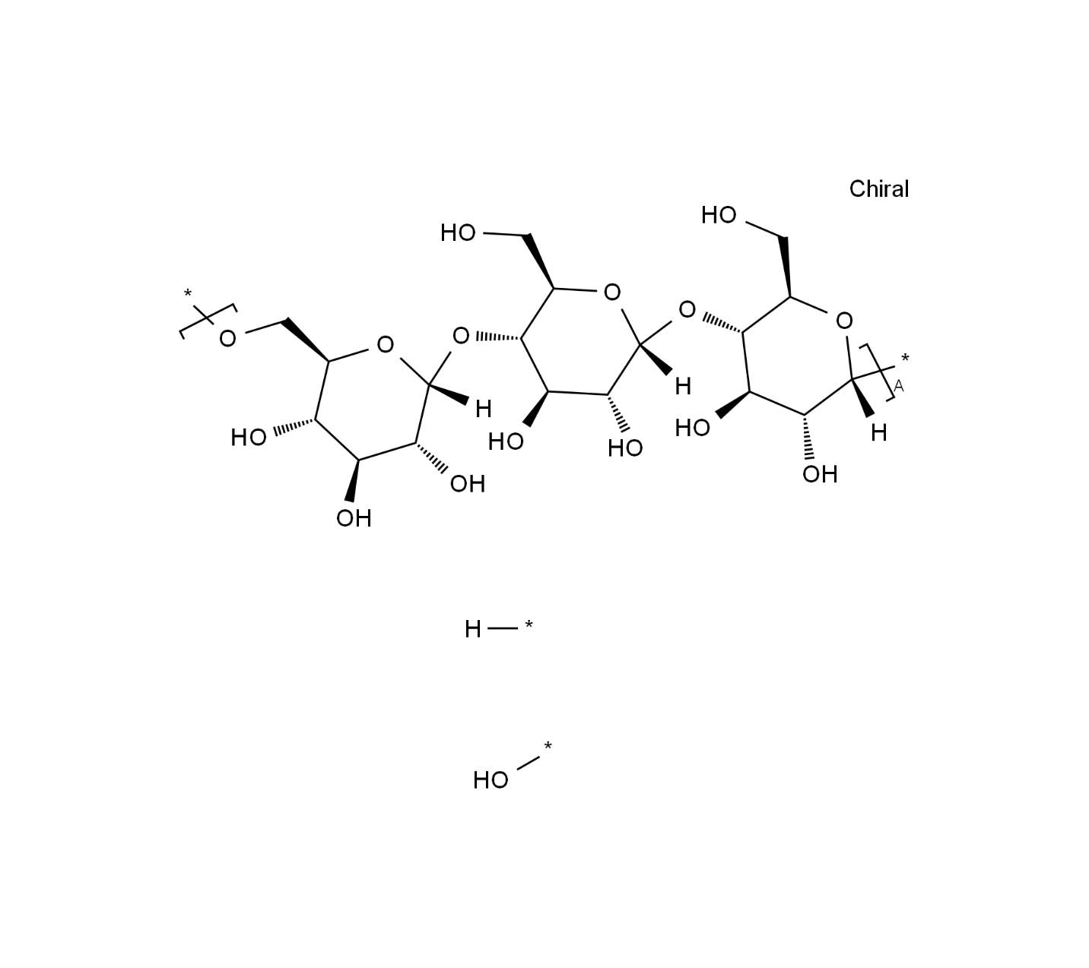

12CA71R8C8

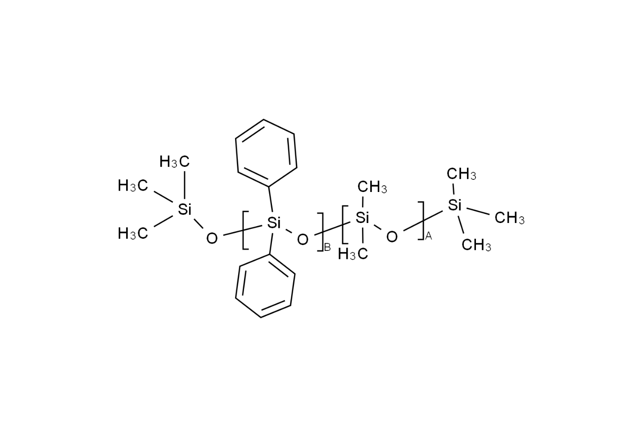

COPOLYMER_LINEAR

0B44BS5IJS

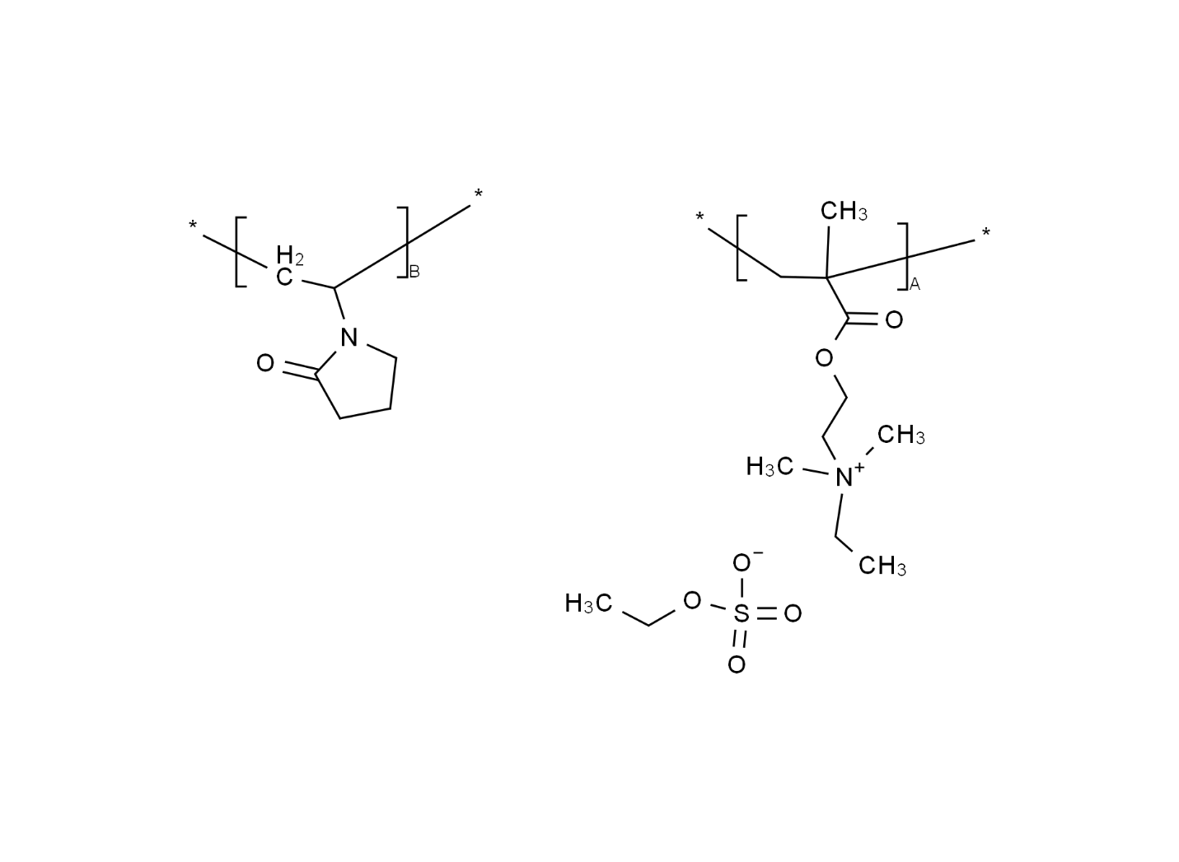

0D05W39TAT

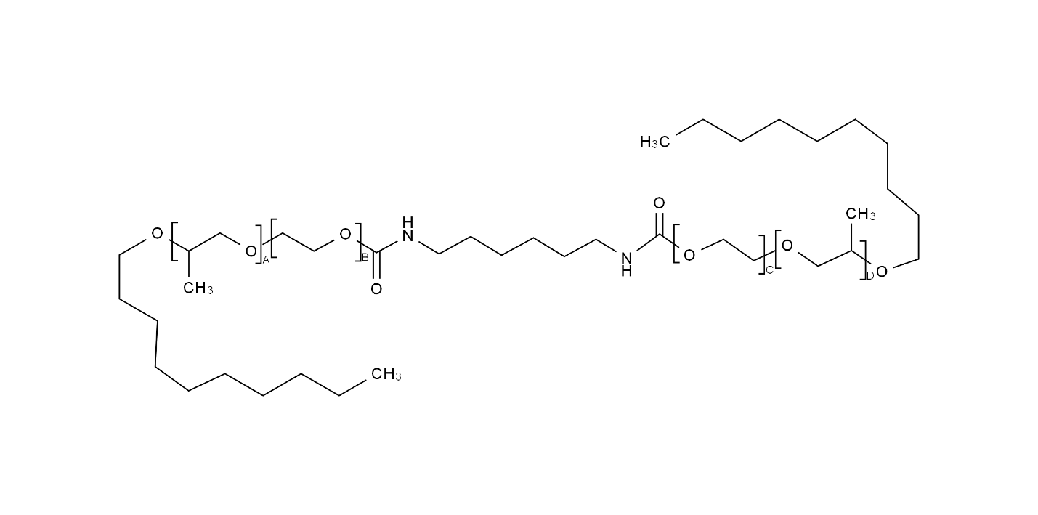

0E2D5DBT7M

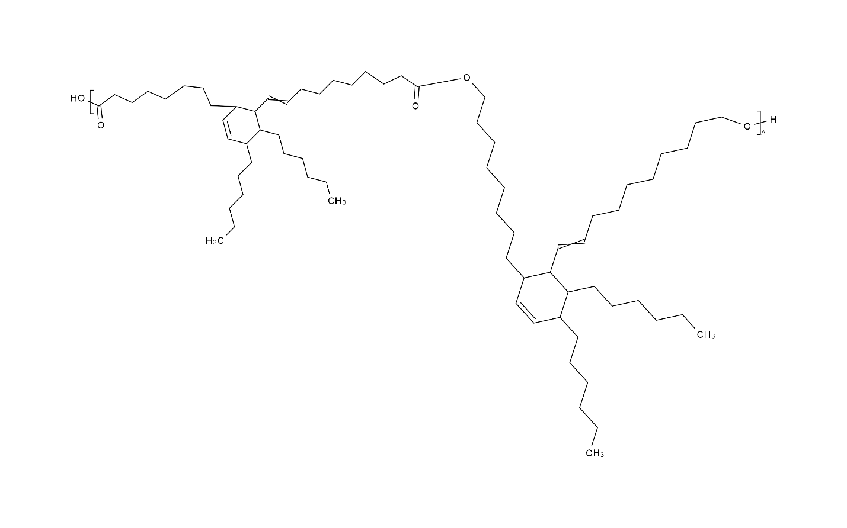

0R79529H48

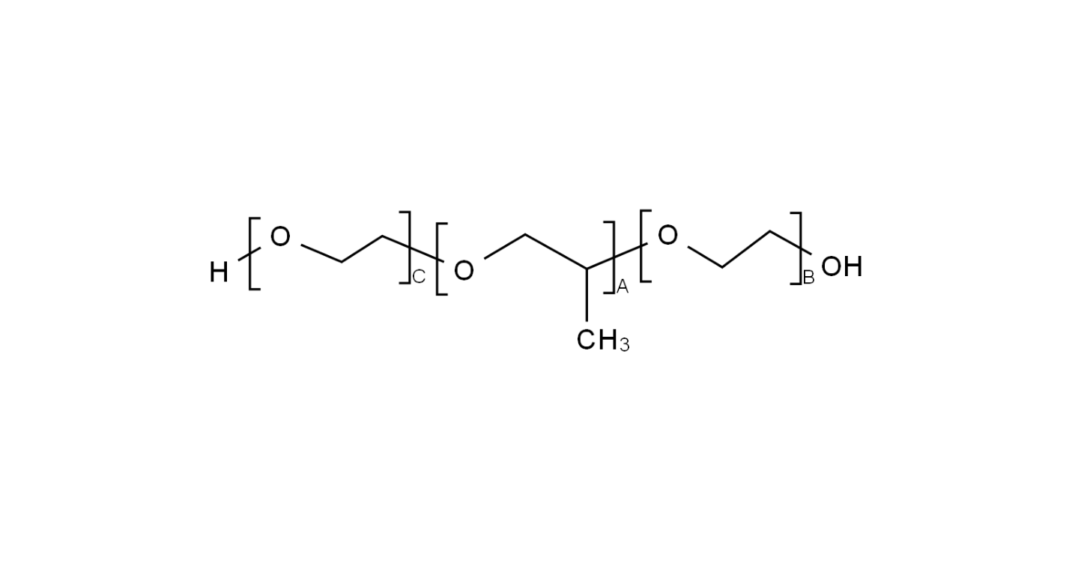

1BK9DDD24E

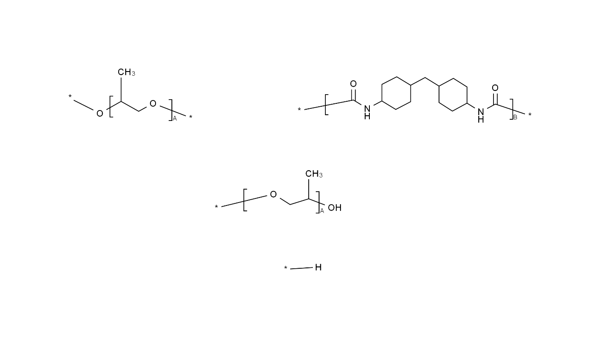

1J0593208B

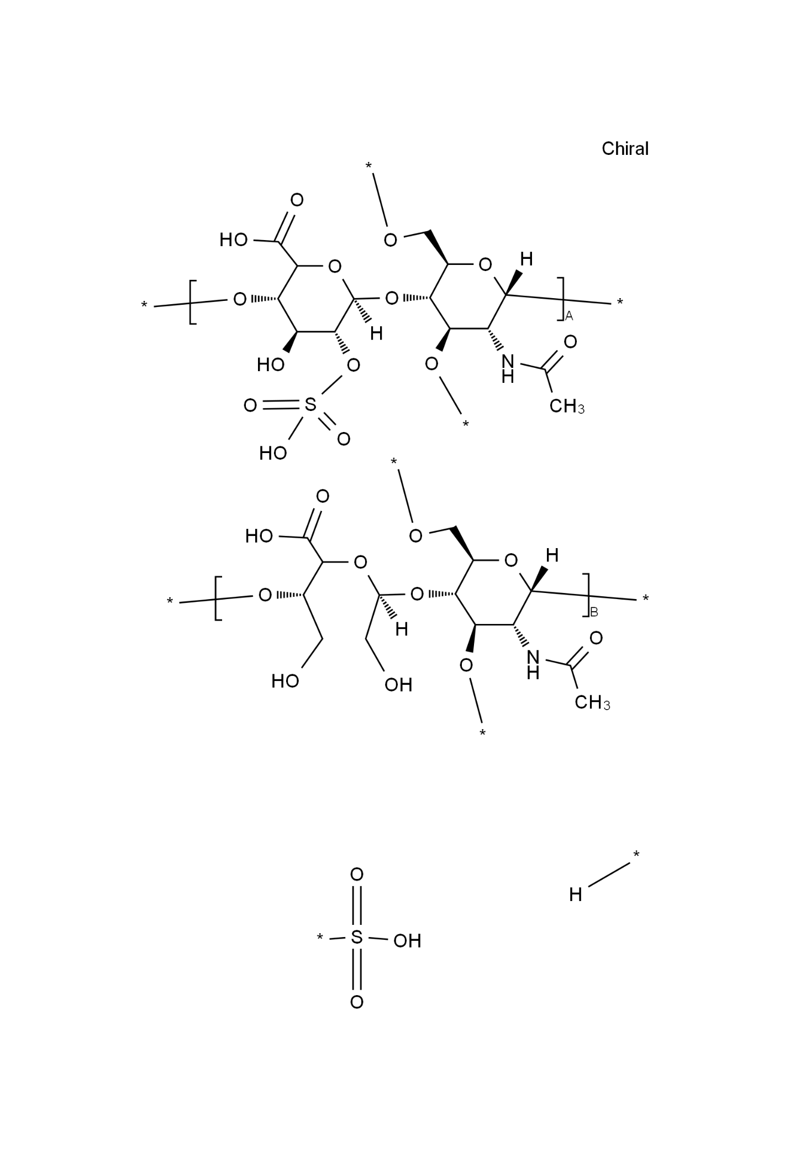

1K5KDI46KZ

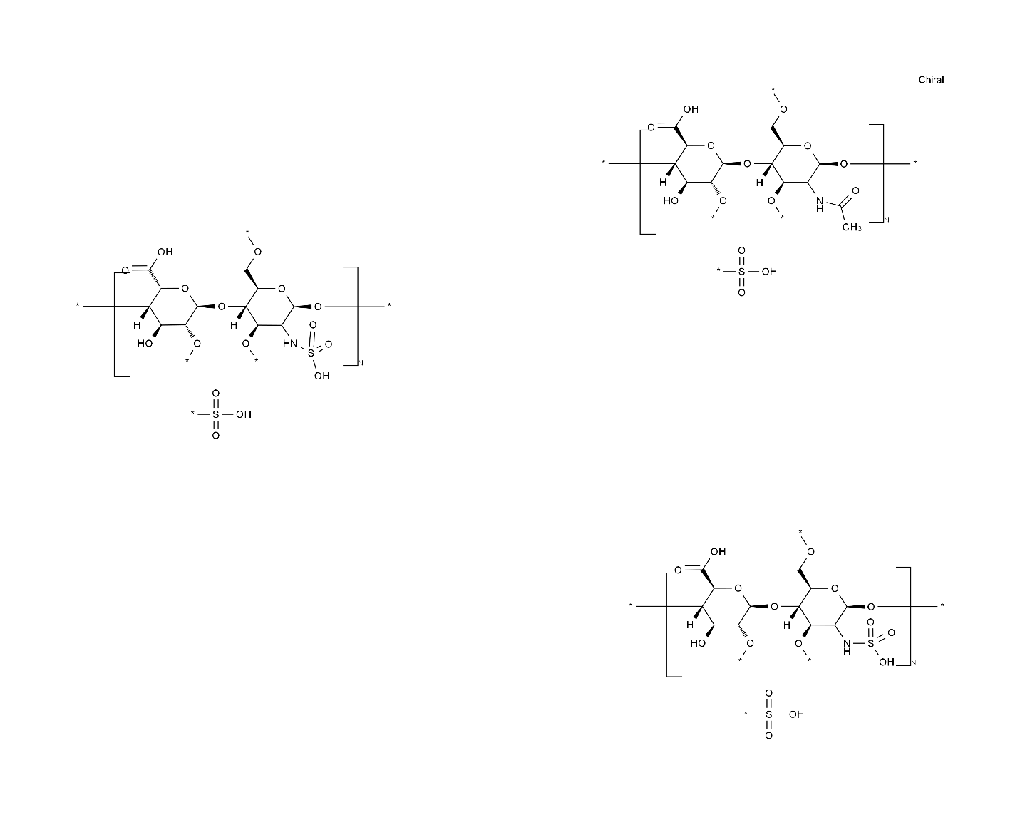

2L9351NW8W

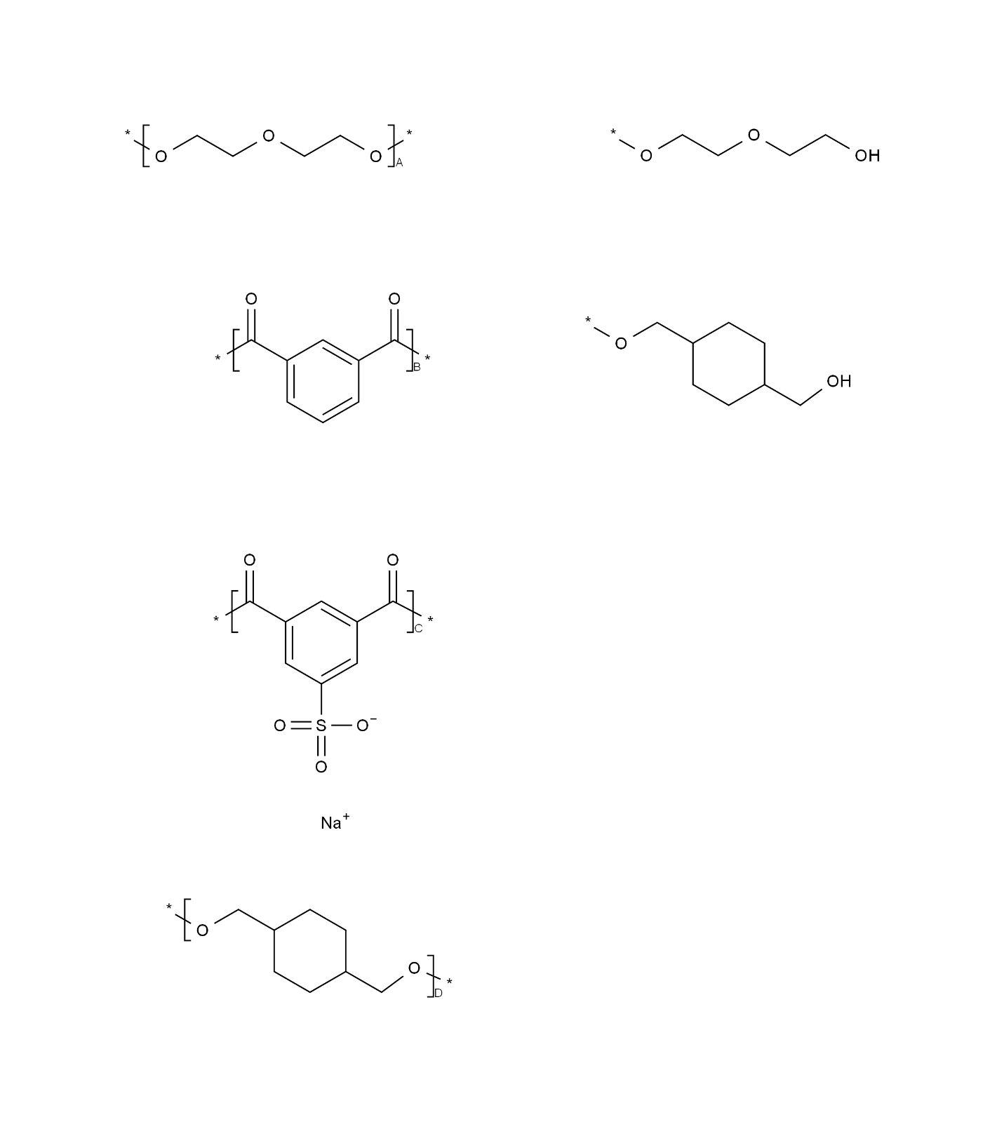

3C785871IX

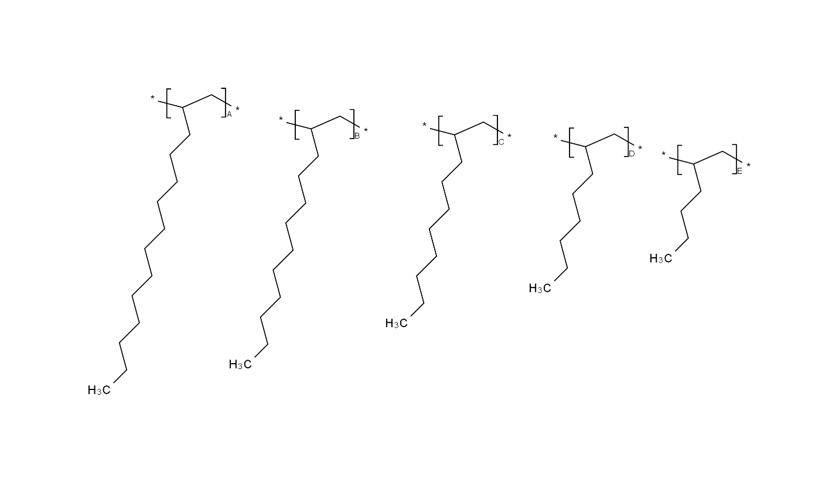

8BZS6Y4IQQ

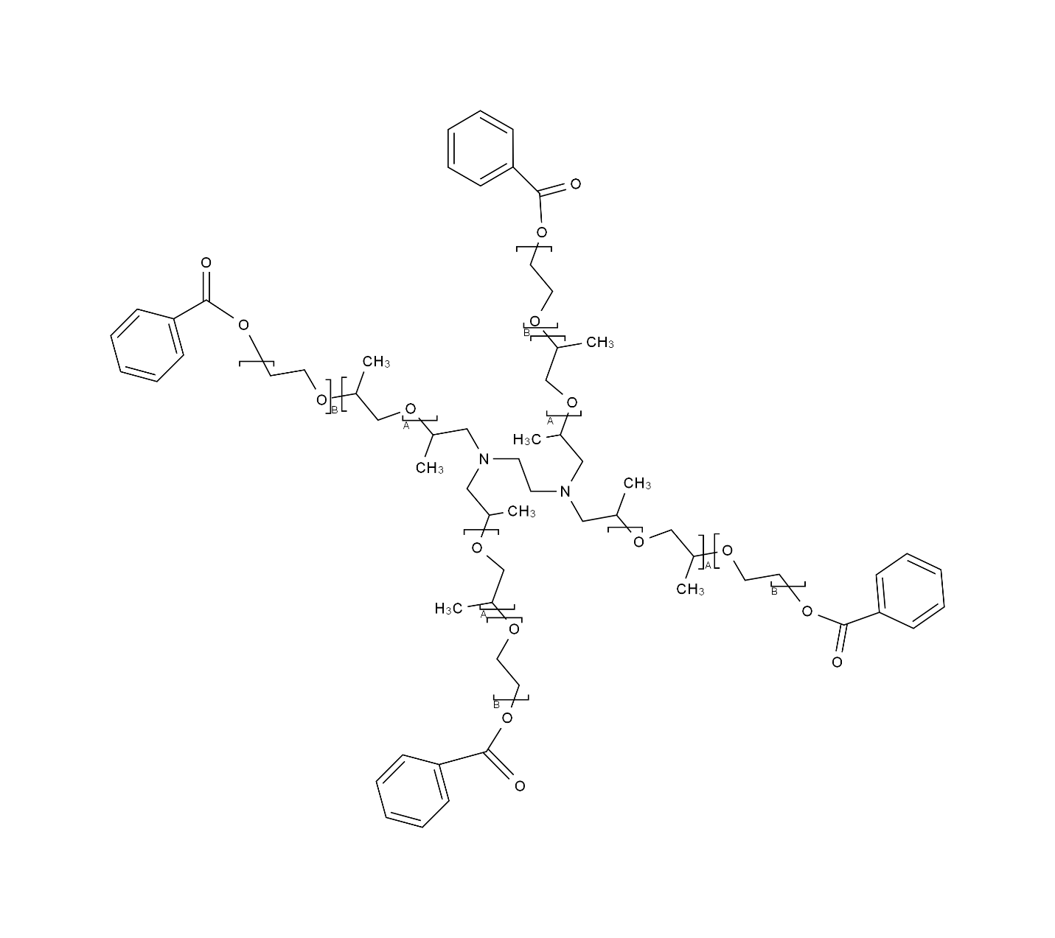

DJN2FGG8Z3

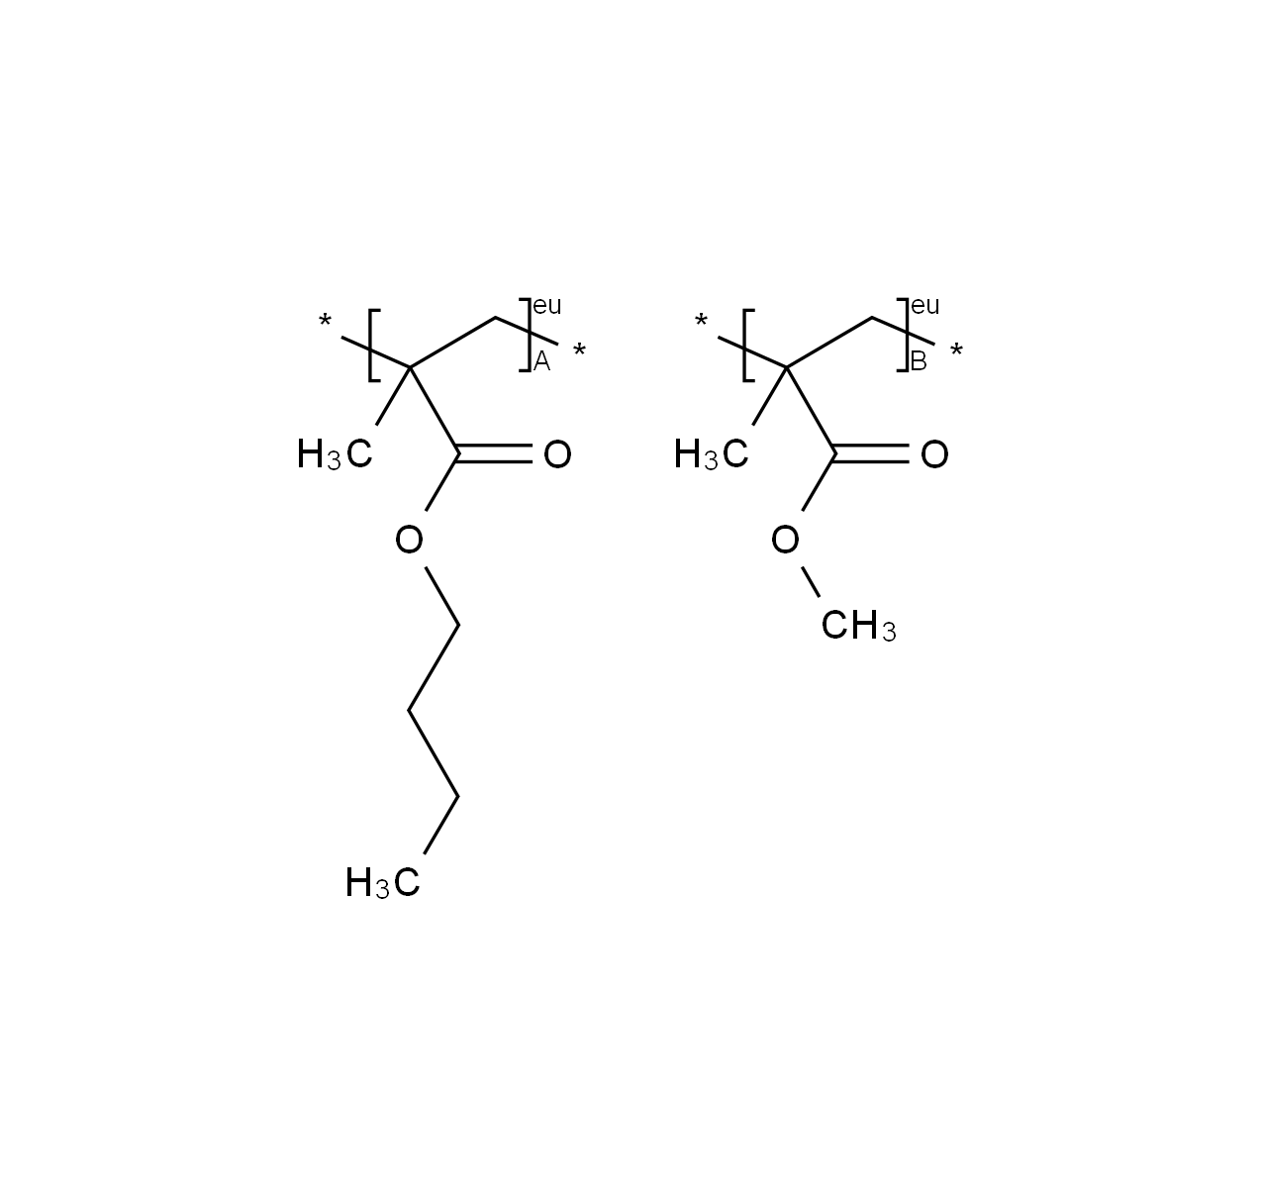

HOMOPOLYMER_BRANCHED

0B2HJ0T27F

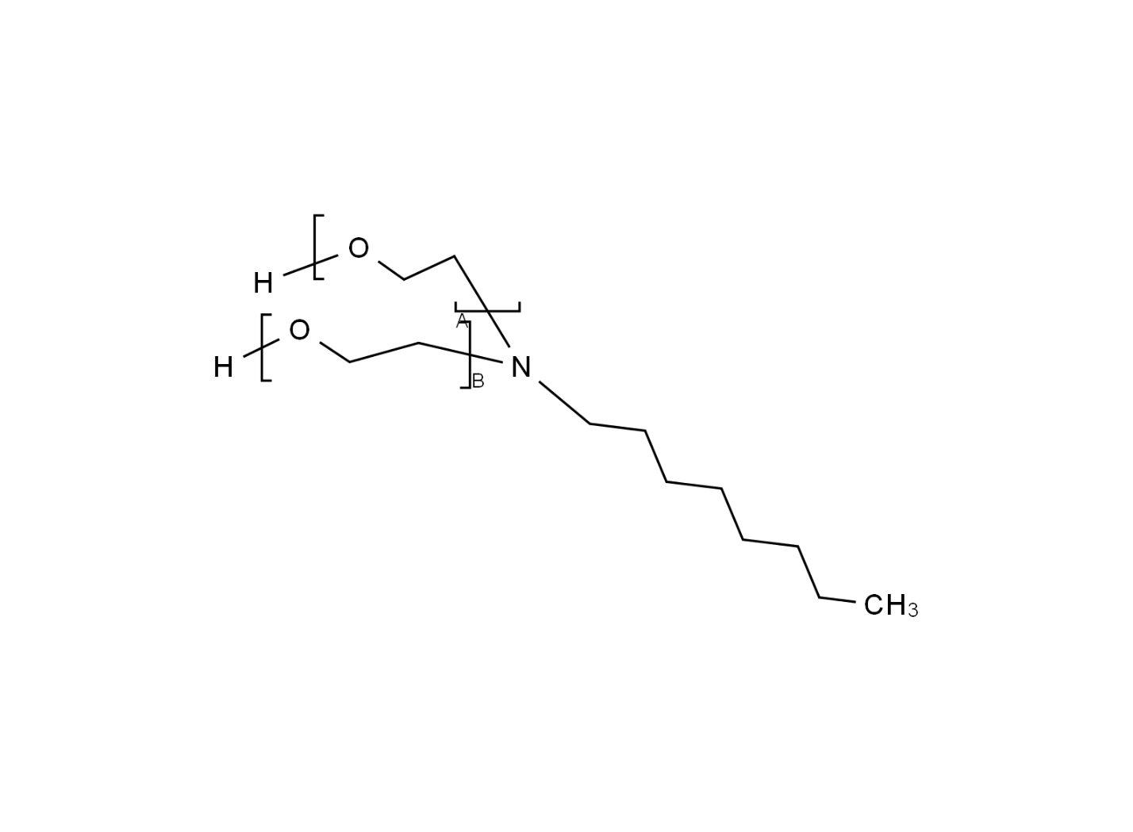

0ED4S93Q0P

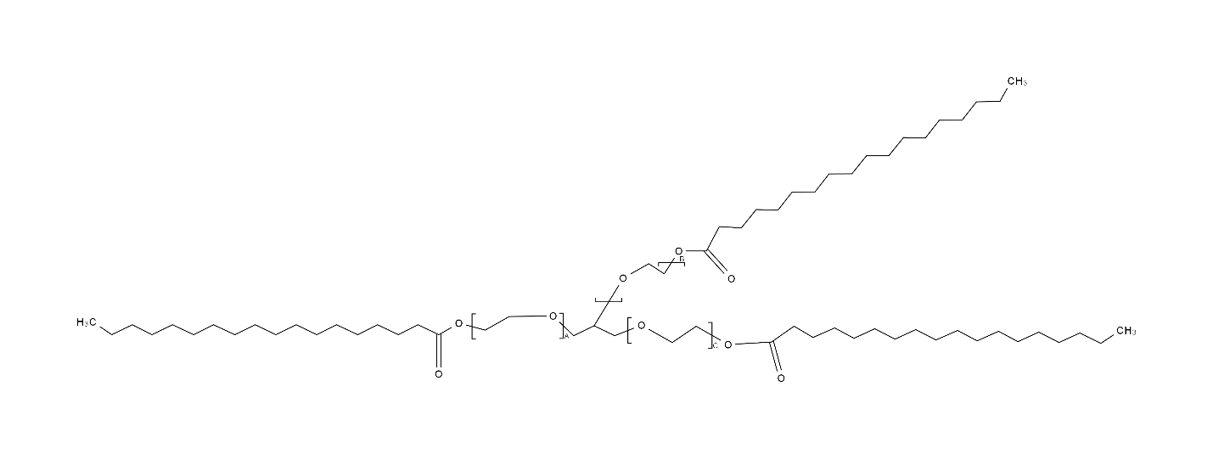

0K3Z895CXH

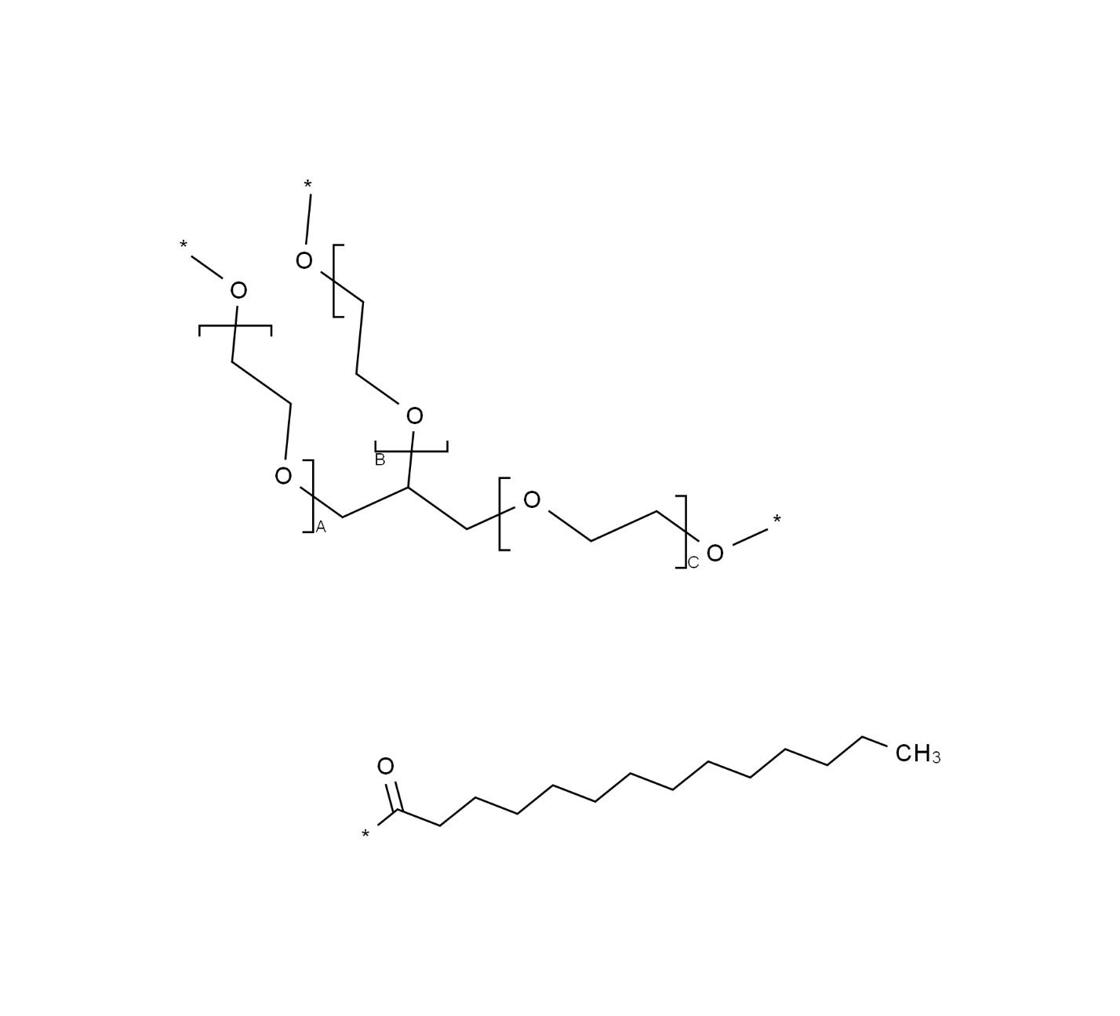

1NHB18SQ8F

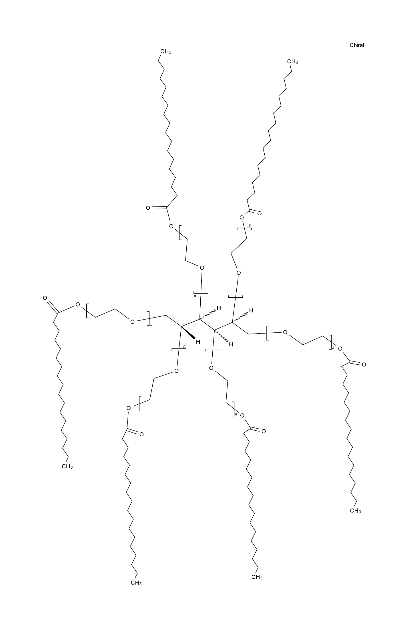

HOMOPOLYMER_CROSSLINKED

30KXI0TVD3

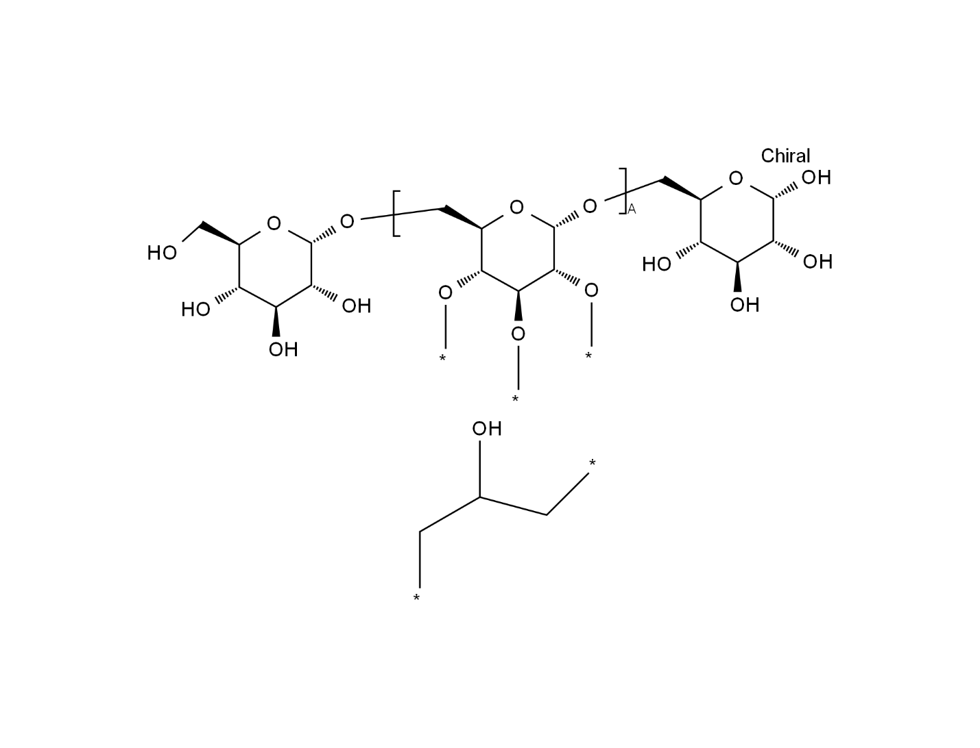

VSI302RYSR

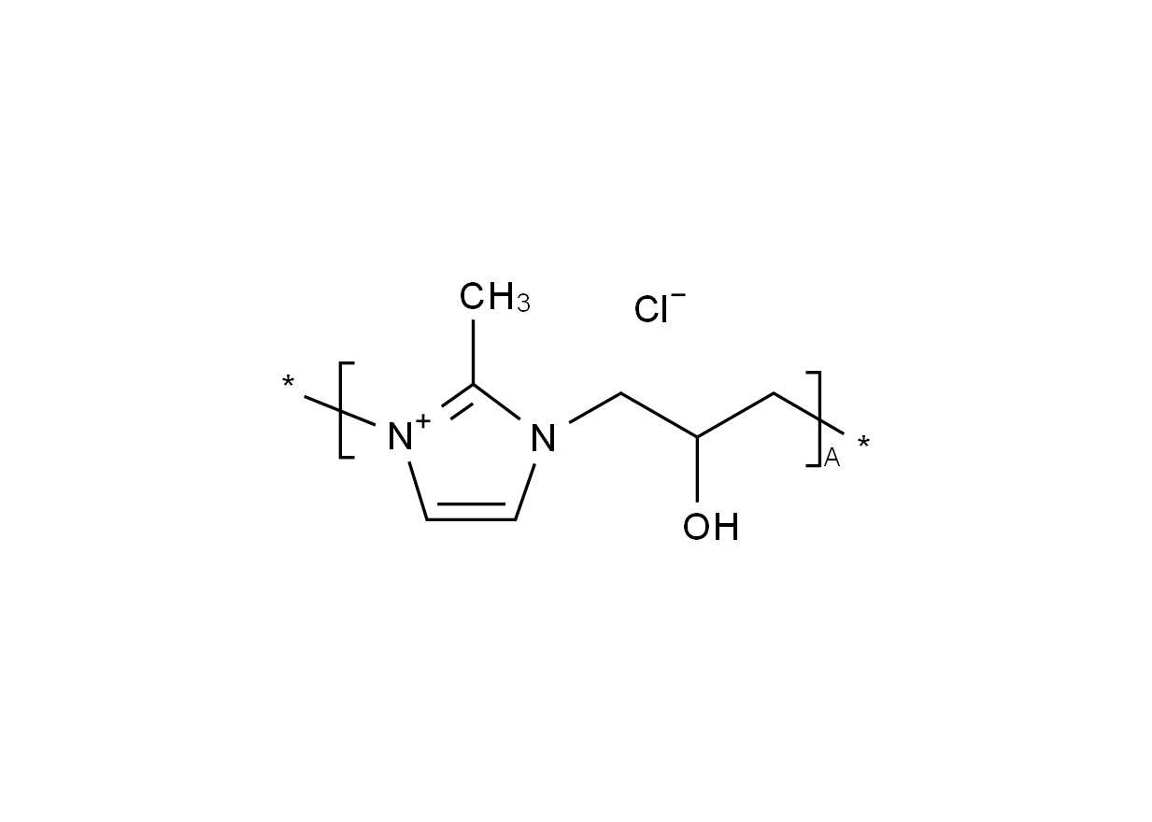

HOMOPOLYMER_CROSSLINKED_NETWORK

4Q93RCW27E

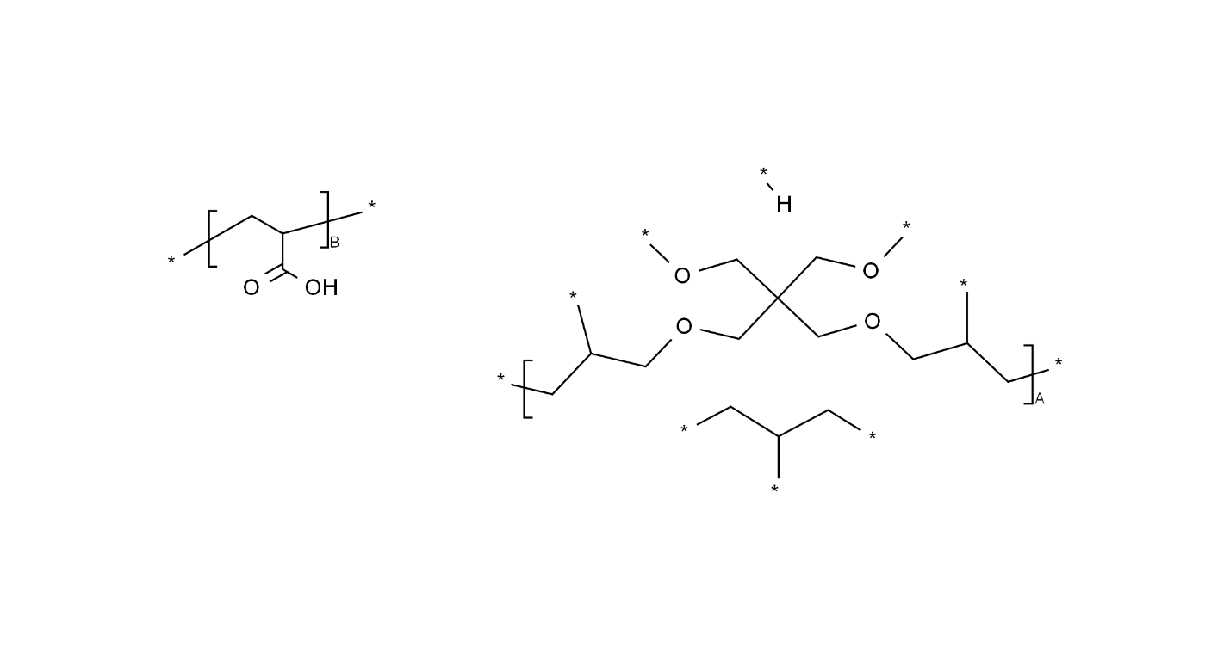

HOMOPOLYMER_GRAFT

7F763NNC9X

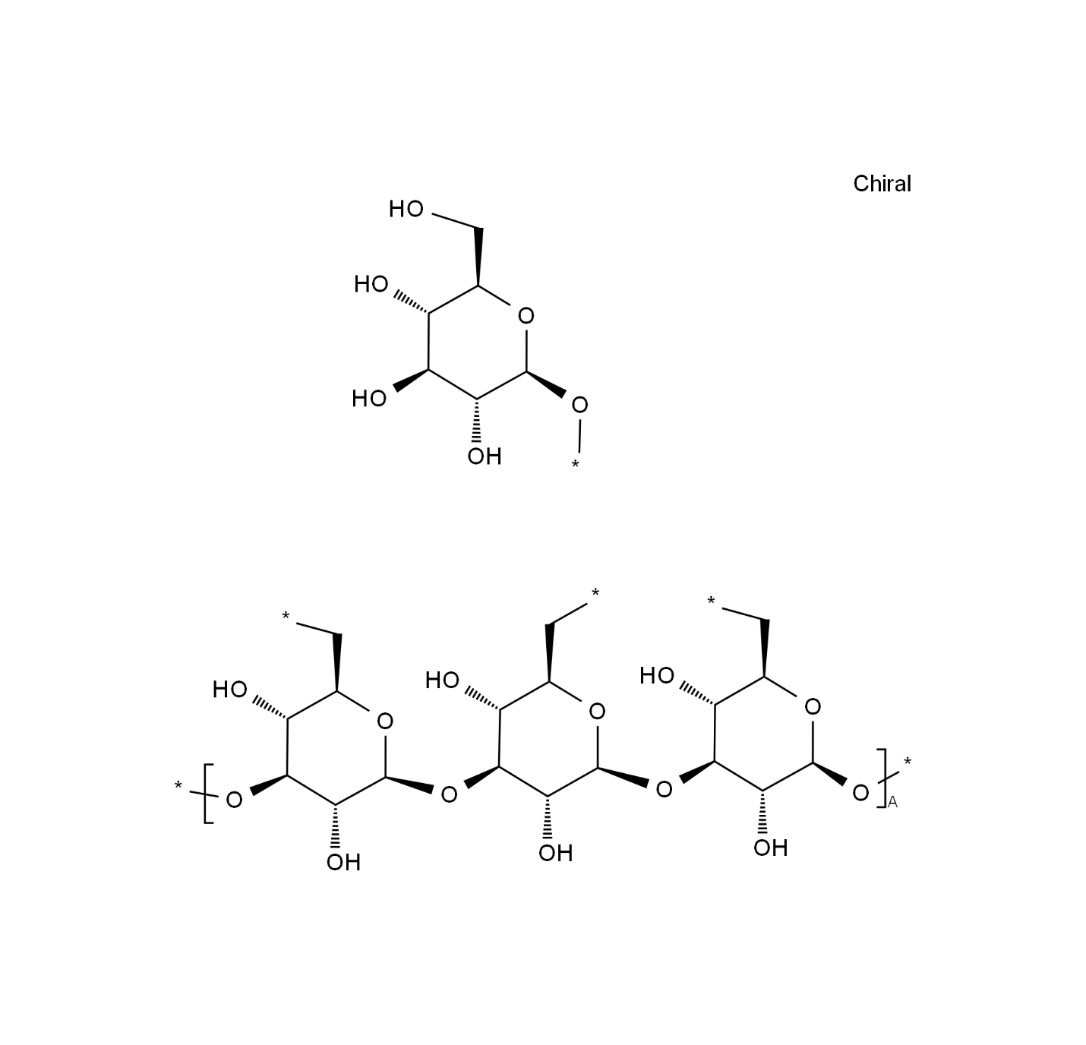

NFX970DSI2

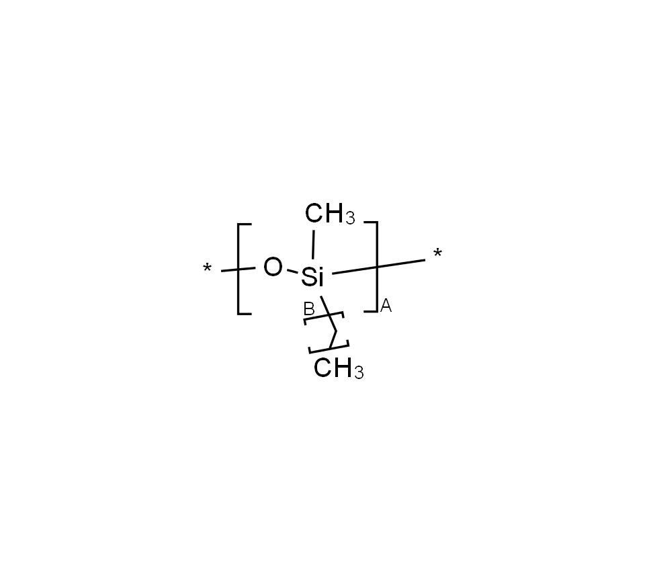

HOMOPOLYMER_SUBSTITUED

0Z2R7OG99L

